==================================================

Running Genetic Algorithm with HistGradientBoosting...

==================================================

==================================================

=== GENETIC ALGORITHM OPTIMIZATION ===

==================================================

[Initialization]

- Population size: 30

- Generations: 20

- Crossover rate: 80%

- Mutation rate: 20%

- Search space: 16 features

- Target: Minimize MSE using HistGradientBoosting

==================================================

=== OPTIMIZATION RESULTS ===

==================================================

▶ Best MSE achieved: 31347498.133356

▶ Time elapsed: 685.18 seconds

▶ Features selected: 16/16 (0.0% reduction)

▶ Selected features:

1. region

2. year

3. manufacturer

4. model

5. condition

6. cylinders

7. fuel

8. odometer

9. title_status

10. transmission

11. drive

12. type

13. paint_color

14. state

15. lat

16. long

▶ Convergence progress:

- Initial MSE: 37218234.6235

- Final MSE: 31347498.1334

- Improvement: 15.8%

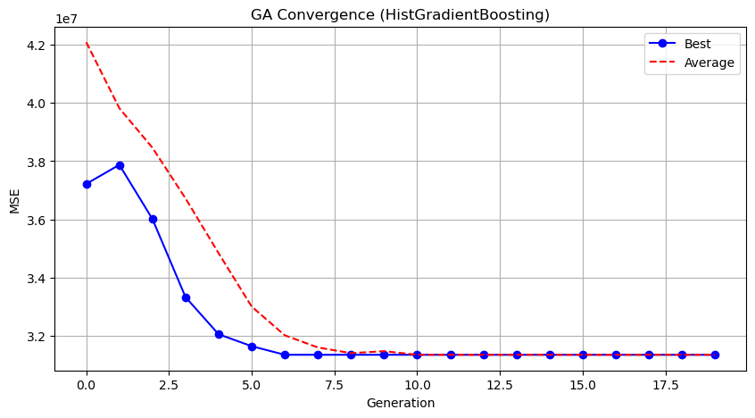

Genetic Algorithm completed successfully with MSE: 31347498.1334

==================================================

Running Particle Swarm Optimization with HistGradientBoosting...

==================================================

==================================================

=== PARTICLE SWARM OPTIMIZATION ===

==================================================

[Initialization]

- Swarm size: 30 particles

- Iterations: 20

- Cognitive weight: 0.5

- Social weight: 0.5

- Inertia weight: 0.5

- Search space: 16 features

- Target: Minimize MSE using HistGradientBoosting

==================================================

=== OPTIMIZATION RESULTS ===

==================================================

▶ Best MSE achieved: 31697738.509357

▶ Time elapsed: 750.80 seconds

▶ Features selected: 13/16 (18.8% reduction)

▶ Selected features (with weights):

1. year (weight: 0.545)

2. manufacturer (weight: 0.588)

3. model (weight: 0.771)

4. condition (weight: 0.702)

5. cylinders (weight: 0.564)

6. fuel (weight: 0.690)

7. odometer (weight: 0.904)

8. transmission (weight: 0.687)

9. drive (weight: 0.562)

10. type (weight: 0.547)

11. paint_color (weight: 0.726)

12. lat (weight: 0.626)

13. long (weight: 0.664)

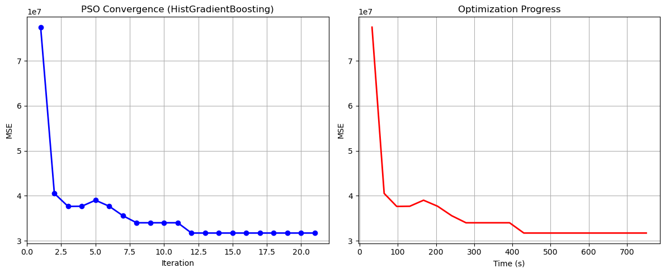

Particle Swarm Optimization completed successfully with MSE: 31697738.5094

==================================================

Running Whale Optimization with HistGradientBoosting...

==================================================

==================================================

=== WHALE OPTIMIZATION ALGORITHM ===

==================================================

[Initialization]

- Population: 30 whales

- Max iterations: 20

- Spiral coefficient (b): 1.0

- Search space: 16 features

- Target: Minimize MSE using HistGradientBoosting

[Optimization Progress]

Iter 20/20 | Best MSE: 31347498.133356

==================================================

=== OPTIMIZATION RESULTS ===

==================================================

▶ Best MSE achieved: 31347498.133356

▶ Time elapsed: 667.93 seconds

▶ Features selected: 16/16 (0.0% reduction)

▶ Selected features:

1. region

2. year

3. manufacturer

4. model

5. condition

6. cylinders

7. fuel

8. odometer

9. title_status

10. transmission

11. drive

12. type

13. paint_color

14. state

15. lat

16. long

▶ Convergence progress:

- Initial MSE: 93280287.3104

- Final MSE: 31347498.1334

- Improvement: 66.4%

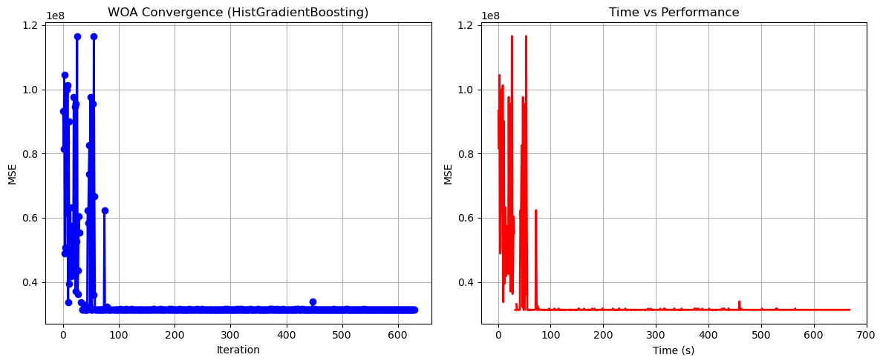

Whale Optimization completed successfully with MSE: 31347498.1334

==================================================

Running Squid Game Optimizer with HistGradientBoosting...

==================================================

==================================================

=== SQUID GAME OPTIMIZER (SGO) ===

==================================================

[Initialization]

- Players: 30 (15 offensive, 15 defensive)

- Max games: 20

- Search space: 16 features

- Target: Minimize MSE using HistGradientBoosting

==================================================

=== OPTIMIZATION RESULTS ===

==================================================

▶ Best MSE achieved: 31731747.625482

▶ Time elapsed: 685.86 seconds

▶ Features selected: 14/16 (12.5% reduction)

▶ Selected features:

1. year

2. manufacturer

3. model

4. condition

5. cylinders

6. fuel

7. odometer

8. title_status

9. transmission

10. drive

11. paint_color

12. state

13. lat

14. long

▶ Convergence progress:

- Initial MSE: 31731747.6255

- Final MSE: 31731747.6255

- Improvement: 0.0%

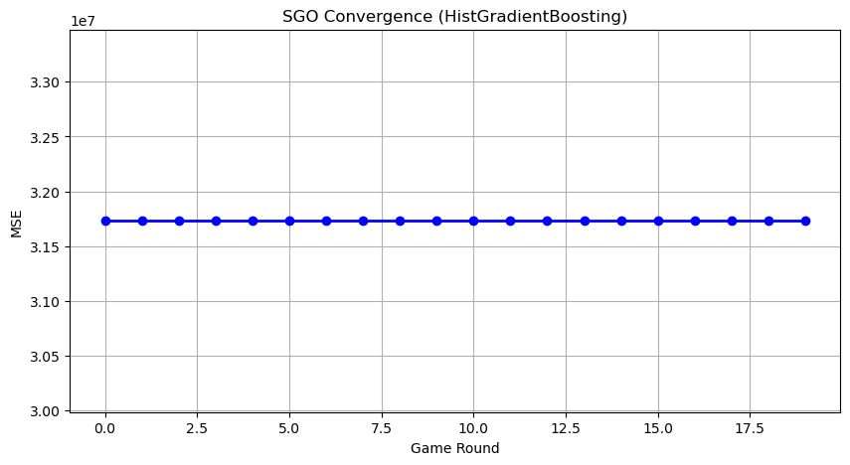

Squid Game Optimizer completed successfully with MSE: 31731747.6255

==================================================

Running PSH-Hyptrite with HistGradientBoosting...

==================================================

==================================================

=== PSH-HYPTRITE OPTIMIZATION ===

==================================================

[Initialization]

- Search points: 30

- Max iterations: 20

- Initial radius: 0.5 (adaptive)

- Hypersphere samples: 3 per point

- Search space: 16 features

- Target: Minimize MSE using HistGradientBoosting

[Optimization Progress]

Iter 20/20 | Best MSE: 31340772.317275 | Radius: 0.0250

==================================================

=== OPTIMIZATION RESULTS ===

==================================================

▶ Best MSE achieved: 31340772.317275

▶ Time elapsed: 2107.70 seconds

▶ Features selected: 14/16 (12.5% reduction)

▶ Selected features (with weights):

1. year (weight: 1.000)

2. manufacturer (weight: 0.604)

3. model (weight: 0.781)

4. condition (weight: 0.695)

5. cylinders (weight: 0.683)

6. fuel (weight: 0.504)

7. odometer (weight: 0.886)

8. title_status (weight: 0.686)

9. transmission (weight: 0.628)

10. drive (weight: 0.961)

11. type (weight: 0.504)

12. paint_color (weight: 0.849)

13. lat (weight: 0.722)

14. long (weight: 0.612)

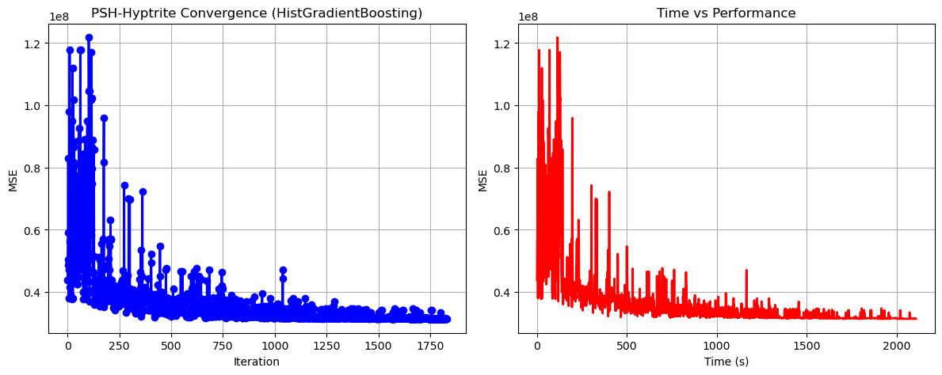

PSH-Hyptrite completed successfully with MSE: 31340772.3173

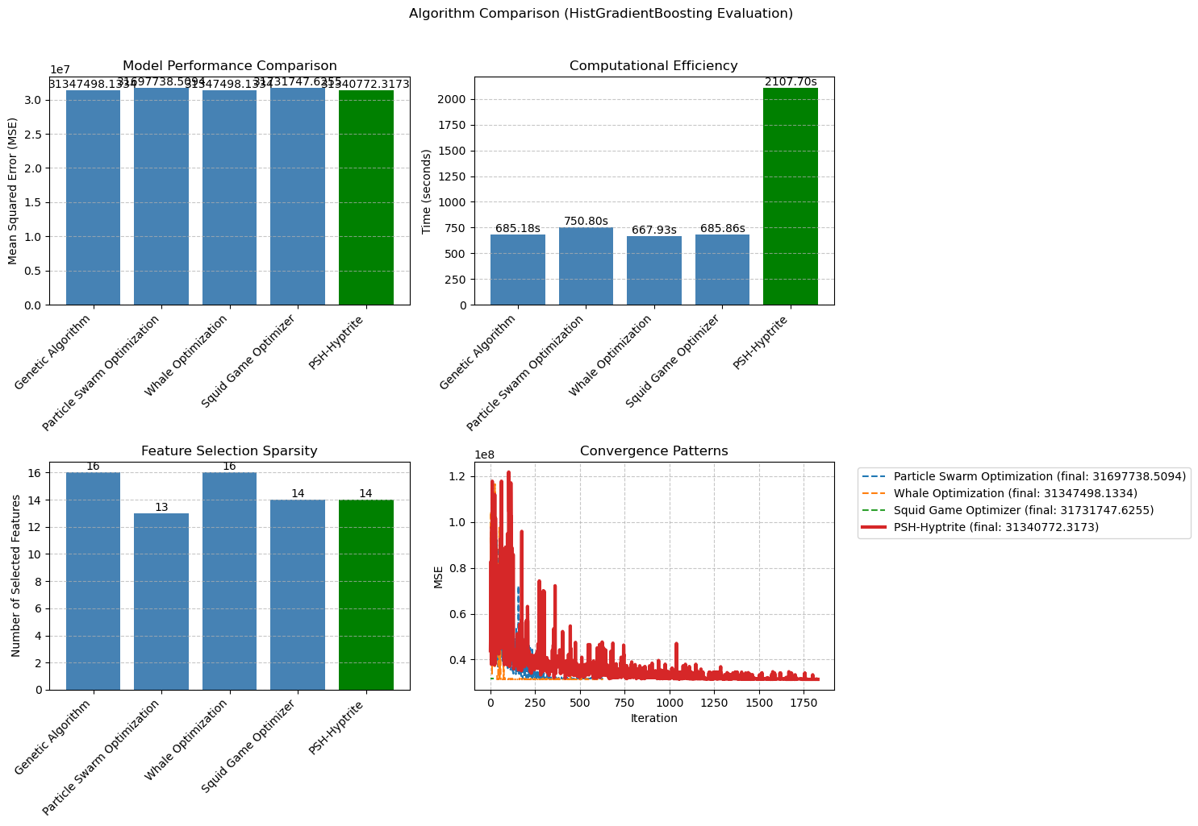

============================================================

=== FINAL FEATURE SELECTION RESULTS USING HistGradientBoosting ===

============================================================

🏆 BEST ALGORITHM: PSH-HYPTRITE

• MSE: 31340772.317275

• Time: 2107.70 seconds

• Features: 14/16 (12.5% reduction)

📊 COMPARISON TABLE:

Algorithm MSE Time (s) Features

---------------------------------------------------------------------------

PSH-Hyptrite 31340772.3172752107.70 14

Genetic Algorithm 31347498.133356685.18 16

Whale Optimization 31347498.133356667.93 16

Particle Swarm Optimization 31697738.509357750.80 13

Squid Game Optimizer 31731747.625482685.86 14

🔍 SELECTED FEATURES:

1. year

2. manufacturer

3. model

4. condition

5. cylinders

6. fuel

7. odometer

8. title_status

9. transmission

10. drive

11. type

12. paint_color

13. lat

14. long

💡 Tip: Consider feature importance from HistGradientBoosting for further analysis